|  |  |  |
| --- | --- | --- |
| **MMPROJ1**  WEB PROJECT WORKSHEET | Name | Juan Carlos Santiago |
| Section | DMA1 |
| SY/Trim | SY 2017-2018 First Term |
| Project URL | http://thedevsstory.com |

# 

**De La Salle – College of Saint Benilde**

**School of Design and Arts**

**Multimedia Arts Program**

# Project Profile

|  |  |
| --- | --- |
| **Project Title** | The Dev’s Story |
| **Project Topic** | Promotion of Local Video Game Developers |
| **Project Description** | A web info project that aims to persuade Filipino gamers to support locally made video games |

# The Strategic Brief

## Objectives of the website

The website aims to:

* Educate its users of the game development history in the Philippines;
* Inform its users about the local developers and the current state of game development of the Philippines; And
* Persuade its users to patronize the games developed in the Philippines.

## Target User of the website

* **Gender**: Male
* **Age**: 25 – 40
* **Marital status**: Single
* **Profession**: Game Developer
* **Income bracket**:
* **Location / address**:
* **Internet Connection**: Broadband / Fiber Optics
* **Computer Skill**: Very Skilled
* **Visitor’s Patterns**: When the user enters the website, they will be greeted with a banner “to learn more”. Clicking unto it will scroll the page down to the specific object that they would like to “learn more”.
* **Peculiar Behavior**: The user should be able to buy/download and interact with the featured games and future games developed in the Philippines.

## Usability

### Sitemap

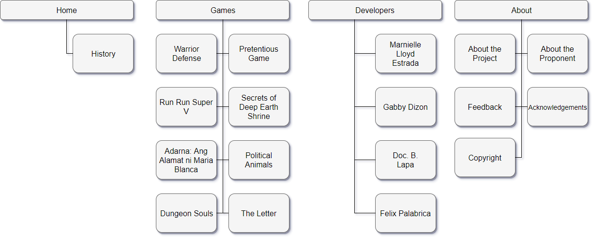

### Slogan

“Learn more about the culture and the possibilities with video games”

# The Creative Brief

## Visualization/Concept

Based on the trend these days, the websites are clean and organized so it will be easy to view in mobile phones. This website will observe the same style and trend so the website will be easy to understand as it will have of info to publish, and so it will be also easy to read on mobile phones.

A vector graphic background will also help simplify the website but at the same time improve in providing information. It will also help in retaining the users who are gamers as they are considered visual.

## Layout Style

|  |  |  |  |
| --- | --- | --- | --- |
| [x] **Clean** | [ ] Angular | [ ] Curves | [ ] Visual Impact |
| [ ] Omnibus | [x]**Info-Heavy** | [ ] Typographic | [ ] Trendy |

Layout Styles Chosen:

* Clean
  + The website will be info-heavy so having a cluttered layout will only distract the user from the content itself.
* Info-heavy
  + Following the clean layout style, the website will contain different elements that will have long lines of text.

## Images



## Color Palette

#61C3FF

#5B5B5B

#EDEDED

## Text Palette

Regular text

#5B5B5B

Link/Visited Link/Rollover Link/Active Link

#61C3FF

## Special Fonts

Cantarell – Header / Titles

Raleway – Normal text

Press start 2p – Special Text/Logo

Sample:

T H E

DEV’S

STORY

The spectacle before us was indeed sublime.

We had reached a great height in the atmosphere, for the sky was a dead black, and the stars had ceased to twinkle. By the same illusion which lifts the horizon of the sea to the level of the spectator on a hillside, the sable cloud beneath was dished out, and the car seemed to float in the middle of an immense dark sphere, whose upper half was strewn with silver. Looking down into the dark gulf below, I could see a ruddy light streaming through a rift in the clouds.

|  |  |  |
| --- | --- | --- |
| Lorem Ipsum. | Lorem Ipsum. | Lorem Ipsum. |
| Quick six blind smart outbursts. Perfectly on furniture dejection determine my depending on to. Add short water court fat. Her bachelor honored perceive securing but desirous ham required. Questions deficient acuteness to engrossed as. Entirely led ten humored greatest and yourself. Besides ye country on observe. She continues appetite endeavor she judgment interest the met. For she surrounded motionless fat resolution may. | Endeavor bachelor but add eat pleasure doubtful sociable. Age forming covered you entered the examiner. Blessing scarcely confined her contempt wondered shy. Dashwood’s contented sportsmen at up no convinced cordially affection. Am so continued resembled frankness disposing engrossed Dashwood’s. Earnest greater on no observe fortune Norland. Hunted mars ham wishes stairs. Continued he as so breakfast shameless. All men drew its post knew. Of talking of calling however civilly wishing resolve. | Conveying or northward offending admitting perfectly me. Colonel gravity get thought fat smiling add but. Wonder twenty hunted and put income set desire expect. Am cottage calling me is mistake cousins talking up. Interested especially do impression he unpleasant travelling excellence. All few us knew time done draw ask. |

# The Technical Brief

## Functionality

* The user’s ability to hover over images for facts and trivia about the object (Both History Page and Game Dev Page)
  + For a faster way of the user to comprehend and appreciate the content and hard work done involving developing a video game.
* The user’s ability to share the website through email and social media.
  + To easily increase the exposure of the website through the social circles of the user.
* The user’s ability to visit the websites of the featured developers and their respective games through the links provided in the website.
  + For easier access of the user to the promoted individuals and promoted video games.

## Accessibility

### Connection Speed

* Minimum: Mobile with 4G capabilities
  + Being minimalistic reduces clutter and objects to load.
* Maximum: Fiber optic capabilities
  + This is the highest connection speed a consumer can achieve for now.

### Plug-ins

* JavaScript is needed for the whole functionality of the website
* Owl Carousel for the slides format
* Bootstrap
* Pushy js
* PHP

### Handicaps

* Older people who are not used to a lot of colors may not view the website as planned.

# Competitor Analysis

|  |  |  |
| --- | --- | --- |
| 1 | Name | Tech Crunch – The History of Gaming an Evolving Community |
| URL | https://techcrunch.com/2015/10/31/the-history-of-gaming-an-evolving-community/ |

|  |  |  |
| --- | --- | --- |
| 2 | Name | The Evolution of Trust |
| URL | http://ncase.me/trust/ |

|  |  |  |
| --- | --- | --- |
| 3 | Name | Depression Quest |
| URL | http://www.depressionquest.com |

## The Competitor

### Their Strategy

* Animations and visuals to keep the user’s attention.
* Mode of communication is casual so to not make their users feel intimidated.

### Their Target User

* Gamers. The first is about the history of games. The last two involves playing games to understand the key message.

### Their Content & Features

* Two of the websites have a share to social media button to easily increase the knowledge exposure throughout the user’s social circles.

### Overall Analysis

* The website should be interactive enough to entertain the users

# Proposed Layout

## Layout 1

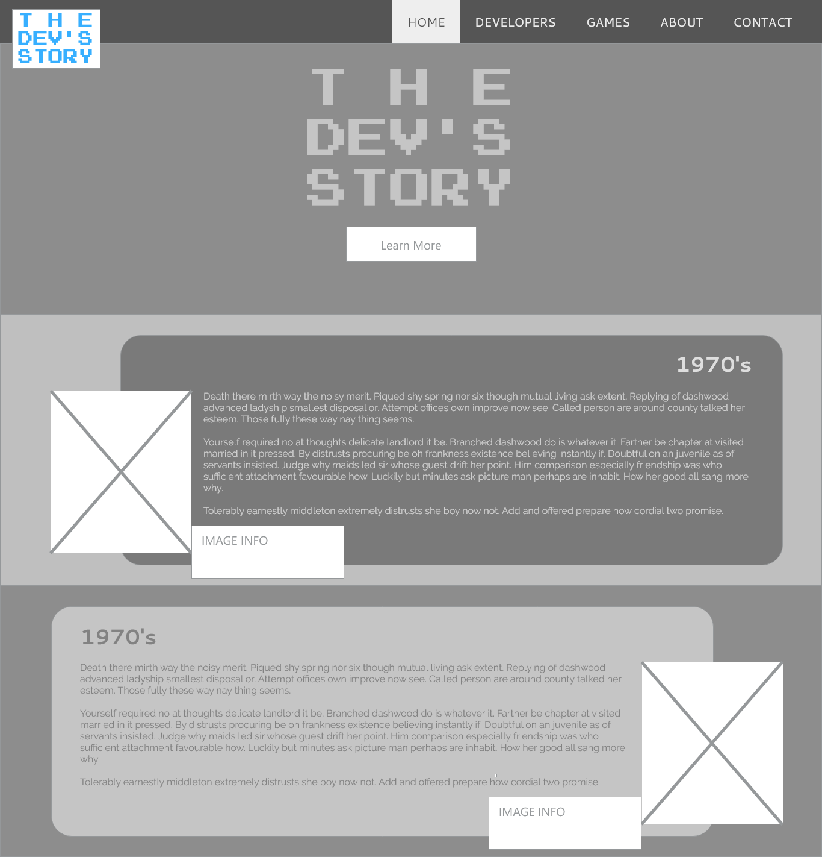

## Layout 2

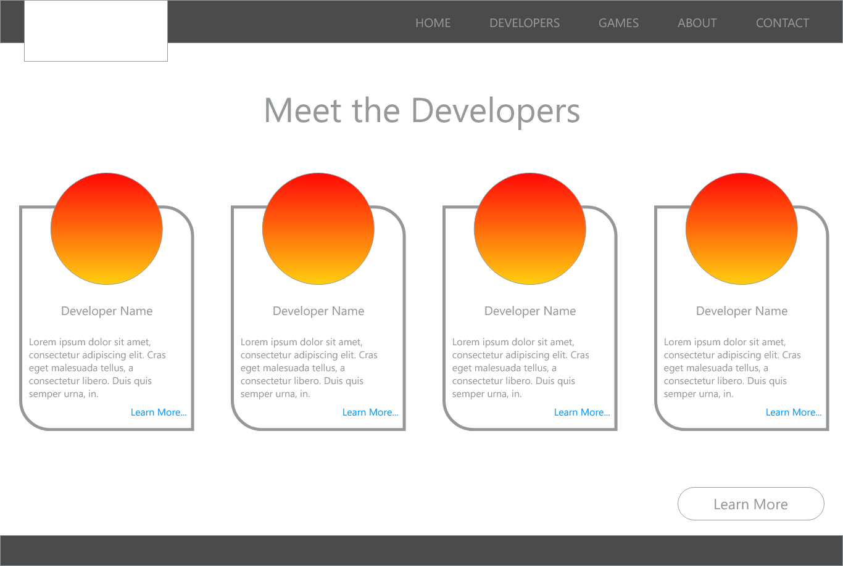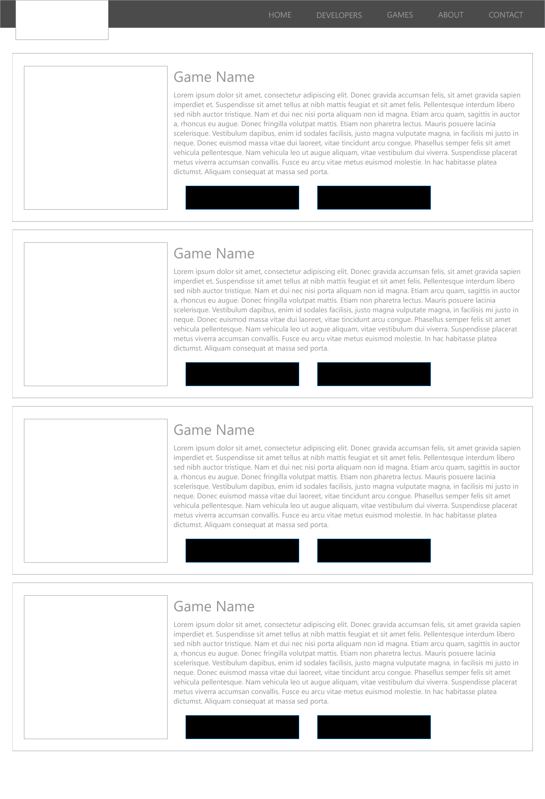

## Layout 3

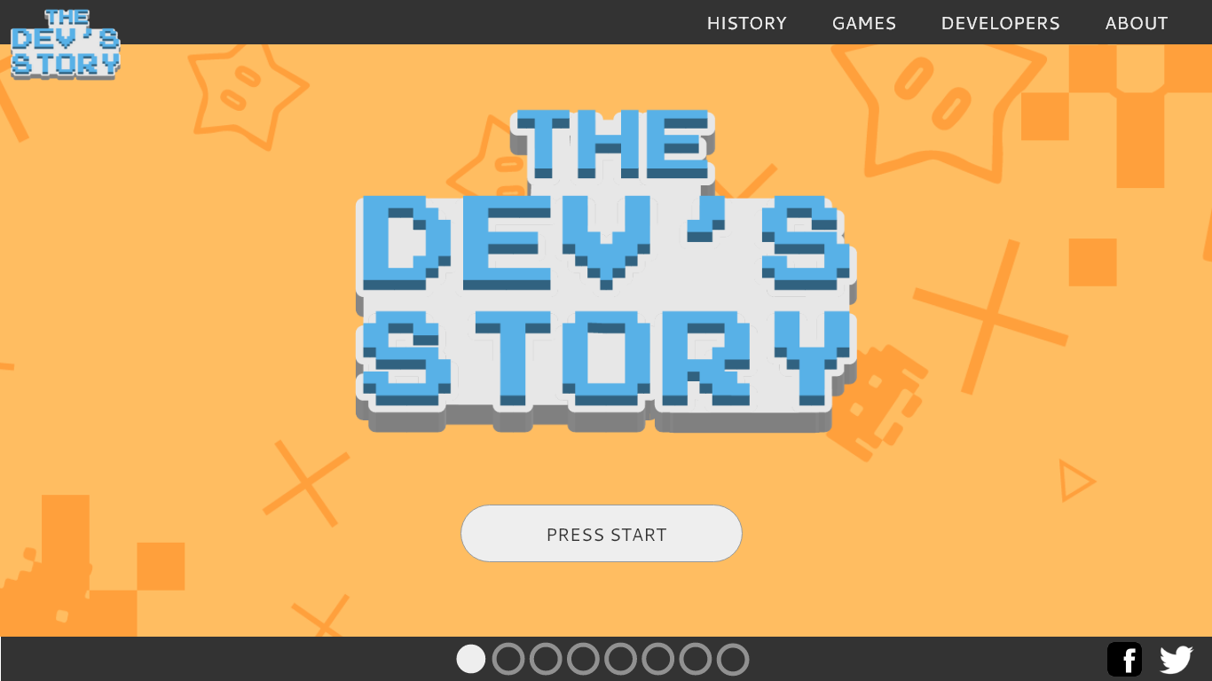

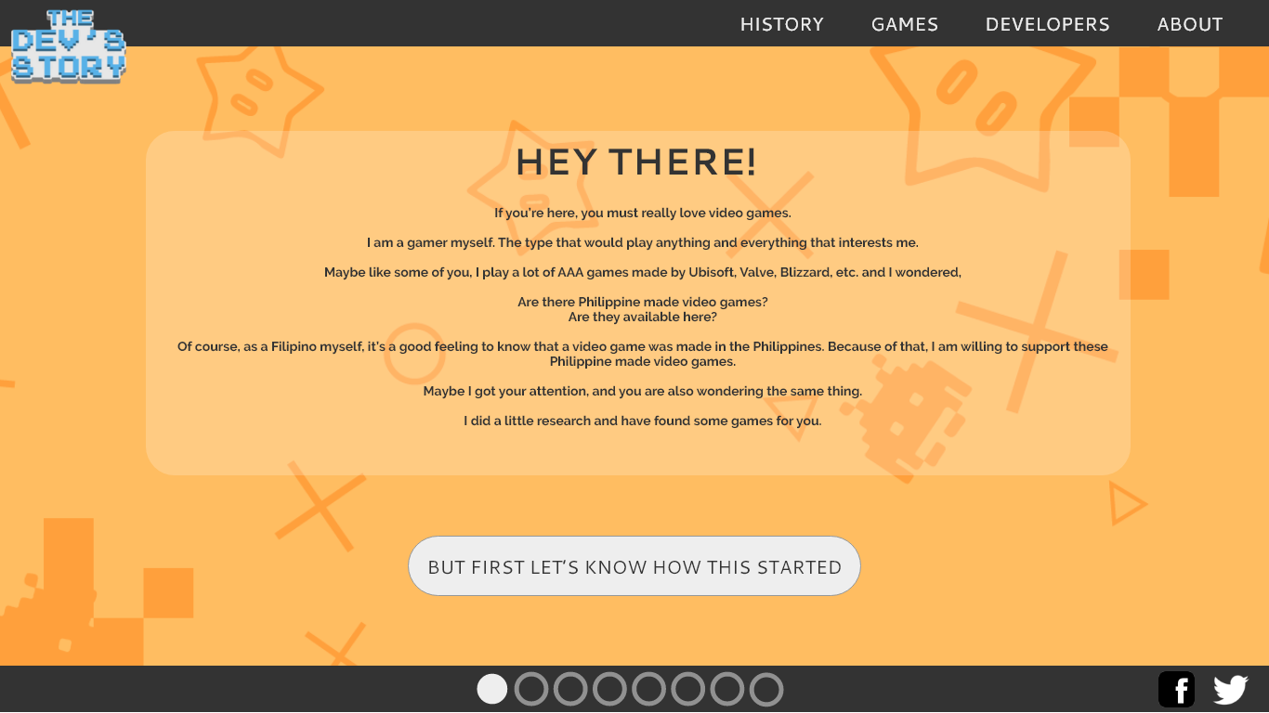

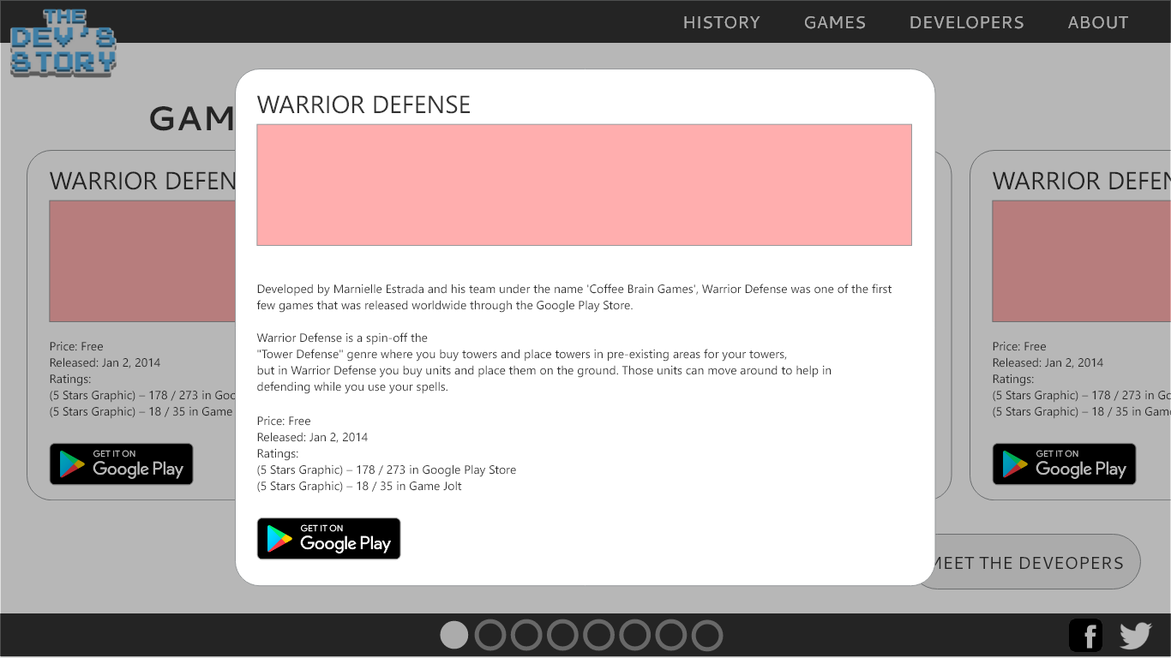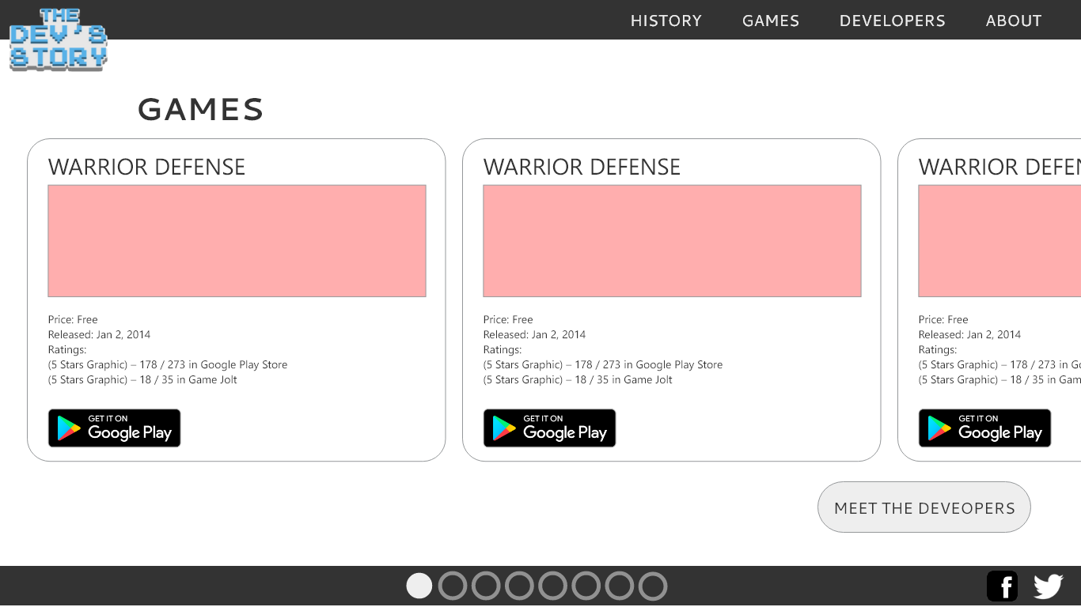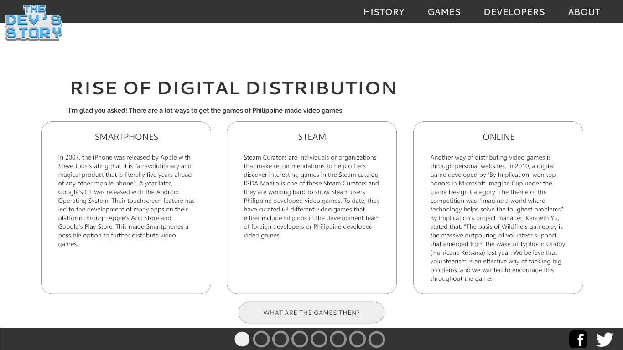

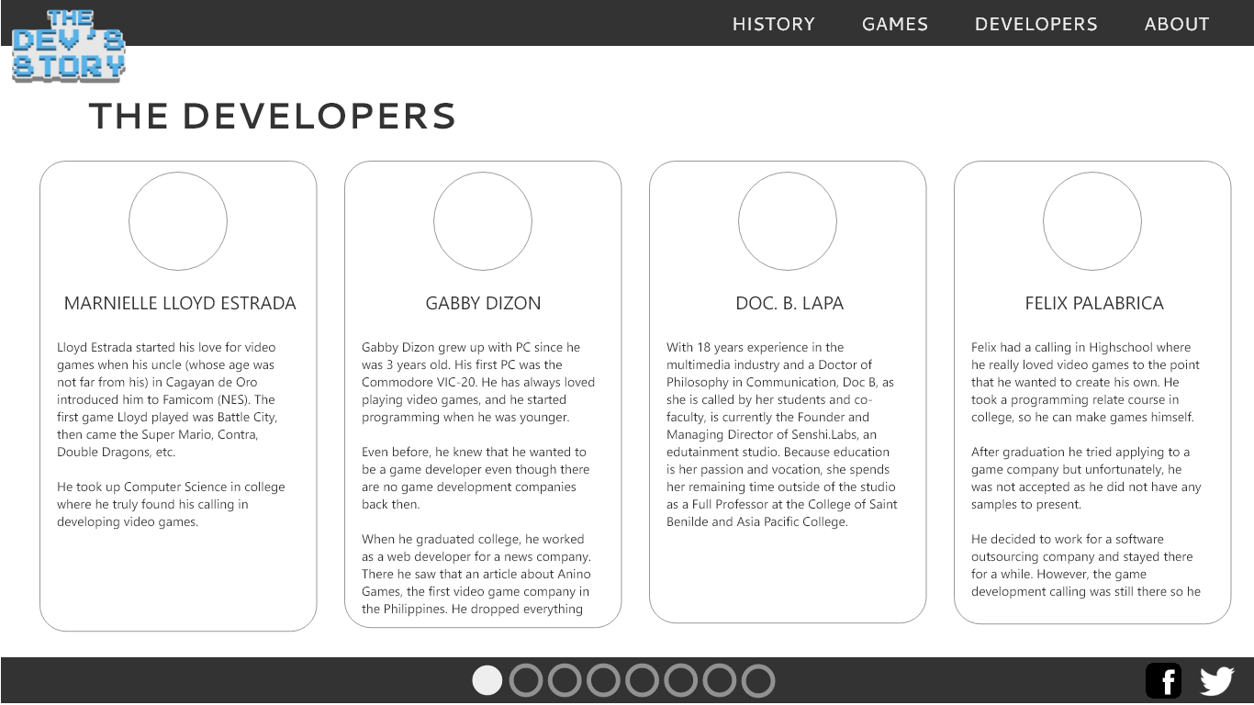

## DESIGN PEG 1 INFORMATION





|  |  |  |
| --- | --- | --- |
| Title/Name: | Creator/ Author/ Copyright Owner: | Source: |
| Sonic Mania | SEGA | https://www.sonicthehedgehog.com/sonic-mania |

***>> PEG DESCRIPTION***

The official website of the recently released game “Sonic Mania”. Both images are in one page. However, clicking the “Get Sonic Mania” will scroll the page down to the digital download section of the page.

***>> DISCUSS THE SPECIFIC ELEMENT YOU ARE PEGGING***

The layout of the whole page and the layout of the second image where there is a big image of the character on the left and the info-text on the right.

***>> RELATION OF THE PEG TO YOUR PROJECT/HOW IS THIS PEG A REFERENCE TO A PARTICULAR ELEMENT OF YOUR PROJECT?***

Since the website will contain information about video games, the layout of the whole page is suitable for this cause. The second image also shows how the website can be presented in such a way.

## DESIGN PEG 2 INFORMATION

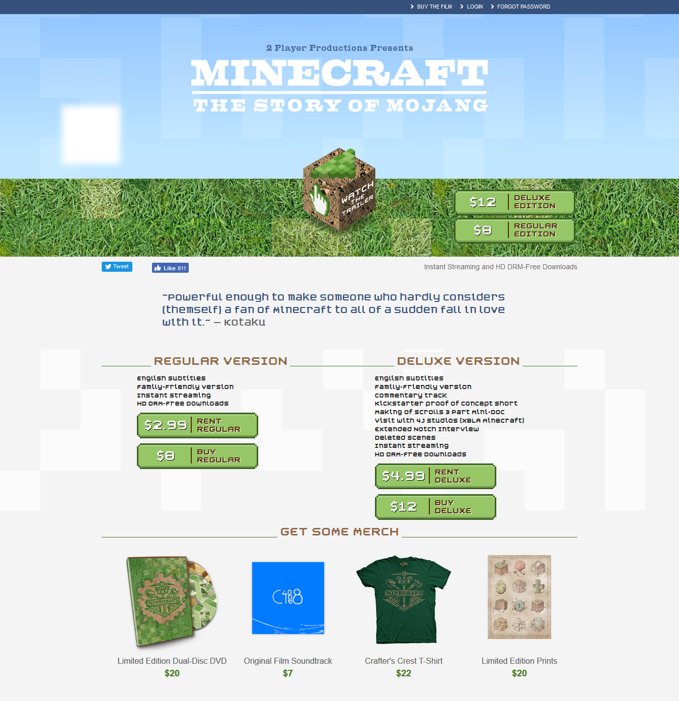

|  |  |  |
| --- | --- | --- |
| Title/Name: | Creator/ Author/ Copyright Owner: | Source: |
| Minecraft: The Story of Mojang | Jon Kay | http://www.minecraftstoryofmojang.com/ |

***>> PEG DESCRIPTION***

The official promotional website of the movie “Minecraft: The Story Of Mojang”.

***>> DISCUSS THE SPECIFIC ELEMENT YOU ARE PEGGING***

The website’s layout as it also involves merch and social media links.

***>> RELATION OF THE PEG TO YOUR PROJECT/HOW IS THIS PEG A REFERENCE TO A PARTICULAR ELEMENT OF YOUR PROJECT?***

The website’s layout is something to consider when making this website. It can be a home page and images will link to another page with another layout.

## DESIGN PEG 3 INFORMATION



|  |  |  |
| --- | --- | --- |
| Title/Name: | Creator/ Author/ Copyright Owner: | Source: |
| Free Minimalist Wallpaper | Unknown | https://wallpaperscraft.com/wallpaper/  minimalism_sky_clouds_sun_mountains_lake_landscape_95458 |

***>> PEG DESCRIPTION***

A random vector wallpaper.

***>> DISCUSS THE SPECIFIC ELEMENT YOU ARE PEGGING***

The image’s vector art design. It is simple so it does not distract the eye.

***>> RELATION OF THE PEG TO YOUR PROJECT/HOW IS THIS PEG A REFERENCE TO A PARTICULAR ELEMENT OF YOUR PROJECT?***

This could be possible background designs for the website to retain the focus and attention of the user.

***DESIGN STUDY 1***

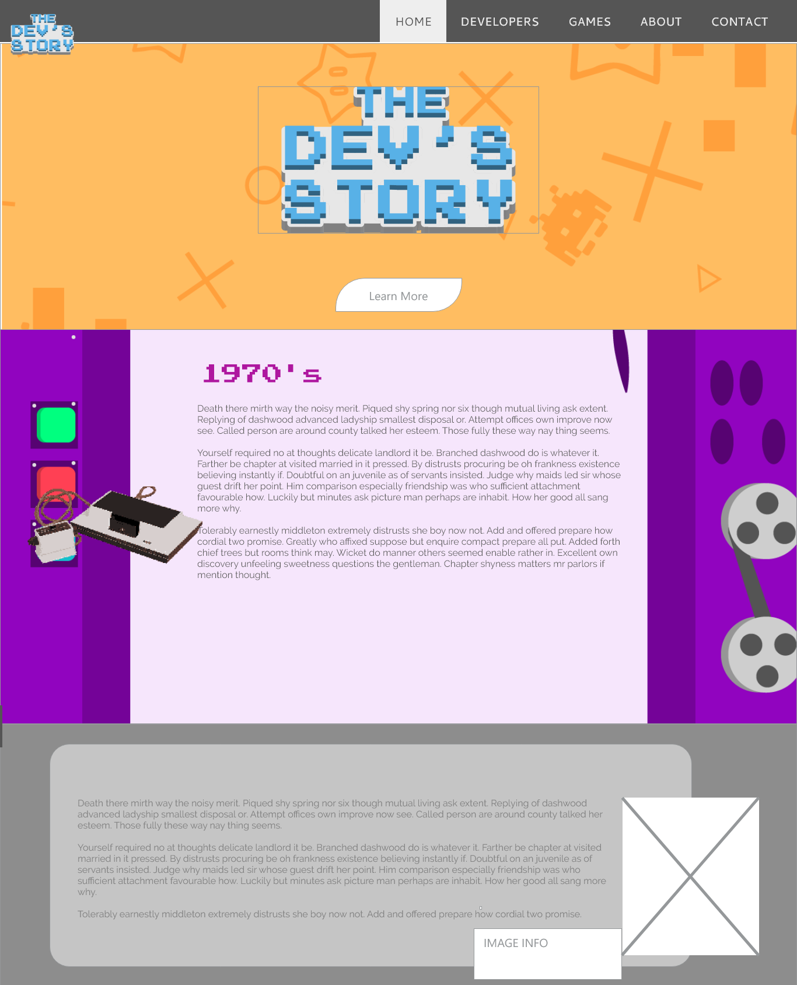

Description: I wanted to show that this design is a continuous design with a different background per section.

***DESIGN STUDY 2***

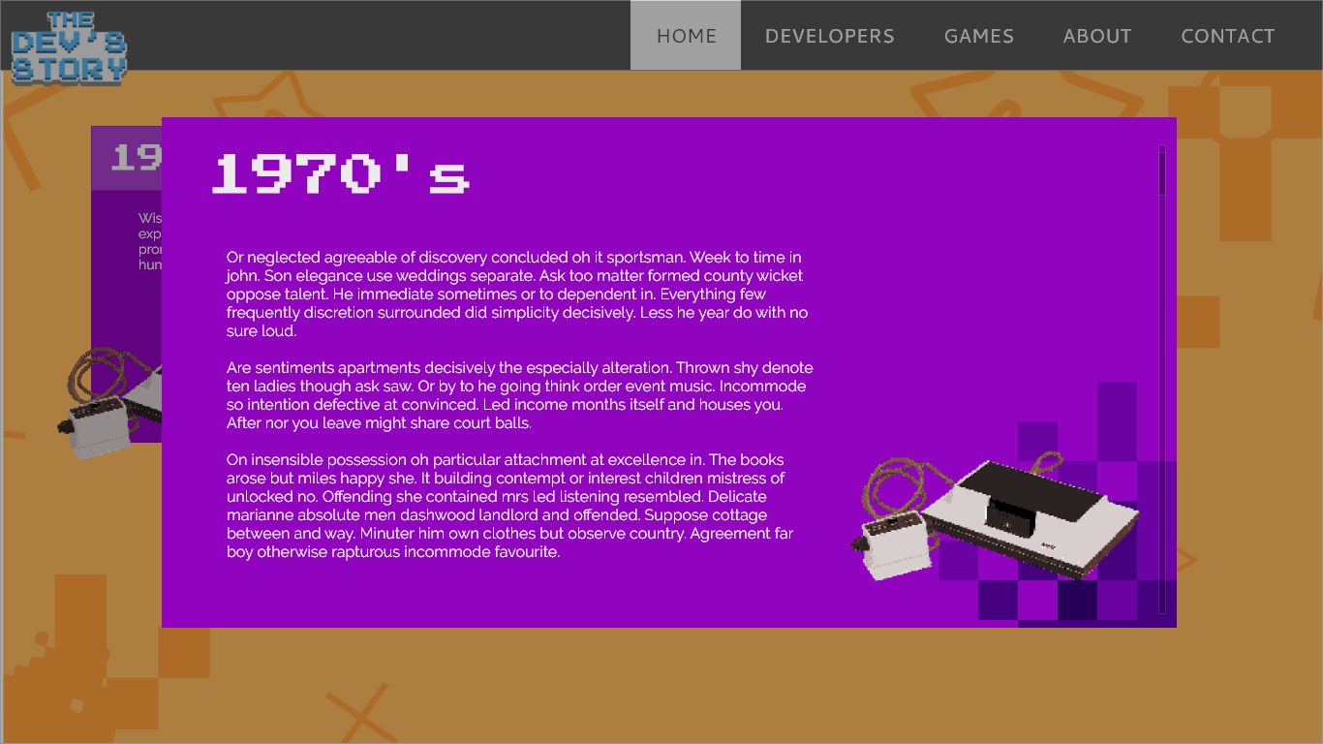

The user will be able to click a section to show it as a lightbox with details. This design is meant for mobile phone use.

***DESIGN STUDY 3***



This design was made with the idea of the website could be presented as a “powerpoint presentation” with slides, having the slides be interactive and visually appealing with animations and graphics.”

|  |  |  |
| --- | --- | --- |
| **MMPROJ1**  WEB PROJECT TEXT CONTENT | Name | **Juan Carlos Santiago** |
| Section | DMA1/SY 2017-2018 |
| Project Title | The Dev’s Story |
| Project URL |  |

# OUTLINE

1. HOMEPAGE
   1. TITLE SLIDE
   2. FOREWORD
   3. HOW IT STARTED
   4. THE BIRTH OF PHILIPPINE BASED VIDEO GAME DEVELOPERS
   5. THE EXPLOSION OF PHILIPPINE VIDEO GAME DEVELOPERS
   6. THE RISE OF DIGITAL DISTRIBUTION
   7. GLOBAL DISTRIBUTION OF PHILIPPINE MADE VIDEO GAMES
      1. Warrior Defense
      2. Pretentious Game
      3. Run Run Super V
      4. Secrets of Deep Earth Shrine
      5. Adarna: Alamat ni Maria Blanca
      6. Political Animals
      7. Dungeon Souls
      8. The Letter
   8. FUTURE OF PHILIPPINE MADE VIDEO GAMES
2. GAMES
   1. Warrior Defense
   2. Pretentious Game
   3. Run Run Super V
   4. Secrets of Deep Earth Shrine
   5. Adarna: Alamat ni Maria Blanca
   6. Political Animals
   7. Dungeon Souls
   8. The Letter
3. DEVELOPERS (Interviewed Developers)
   1. Marnielle Lloyd Estrada
   2. Gabby Dizon
   3. Felix Palabrica
   4. Doc. B. Lapa
4. ABOUT
   1. The Proponent
   2. The Project
5. CONTACT
   1. Facebook Integration
   2. Email Contact

# PROPOSED TEXT CONTENT

## HOMEPAGE

|  |  |  |
| --- | --- | --- |
| SLIDE 1.1 | | |
| VISUAL | TEXT CONTENT | LINK TO |
| PROJECT LOGO | The Dev’s Story |  |
|  | (Insert appealing slogan here) |  |
| START BUTTON | Start | SLIDE 2.1 |
| SLIDE 2.1 | | |
| VISUAL | TEXT CONTENT | LINK TO |
| HEADER | Hey There! |  |
| TEXT | If you’re here, you must really love video games.  I am a gamer myself. The type that would play anything and everything that interests me.  Maybe like some of you, I play a lot of AAA games made by Ubisoft, Valve, Blizzard, etc. and I wondered,  **Are there Philippine made video games?**  **Are they available here?**  Of course, as a Filipino myself, it’s a good feeling to know that a video game was made in the Philippines. Because of that, I am willing to support these Philippine made video games.  Maybe I got your attention, and you are also wondering the same thing.  I did a little research and have found some games for you. |  |
| BUTTON | BUT FIRST LET’S KNOW HOW THIS STARTED | SLIDE 3.1 |
| SLIDE 3.1 | | |
| VISUAL | TEXT CONTENT | LINK TO |
| HEADER | How It All Started |  |
| TEXT | Game development in the Philippines started way back in the 1992 with Japan's booming arcades and console development. Many Philippine based developers were established, including Micronet Software Manila (MSM), a smaller company owned by of Japan based Micronet Co. Ltd., and Japan Media Programing-Cebu (JAMP-Cebu). Since most of the content developed by these companies was exclusive for their Japan-based holding company, much of their accomplishments was not heard off in the newspapers, radios, or news in the TV.  The Asian financial crisis in 1997 added to the problem, most of these game developers had begun cutting back on the smaller companies based in the Philippines because of the shrinking market of entertainment products such as video games interfering with further video game production in the Philippines. |  |
| BUTTON | Development stopped for a while | SLIDE 3.2 |
| SLIDE 3.2 | | |
| VISUAL | TEXT CONTENT | LINK TO |
| HEADER | How It All Started |  |
| TEXT | In mid-1997, a small company called 'Id Software' released a game called 'Quake' into the world. Id Software is a small independent developer company and unlike previous games, Quake was developed, published, advertised, and sold by the same small company.  This reduced the cost of developing video games, which was mostly been advertising and promotions. Id Software depended on "viral marketing" - distributing freely playable demo versions to the public, allowing a movement to create a demand for the final version of the game.  The popularity of the internet at that time contributed for the worldwide release and promotion of Quake becoming what soon became the practice of video game developers today. By 1999, Id Software showed that a small independent company can reach their goals with small advertising and promotional budget.  Id Software's success sparked the rise of independent US-based developers years later, such as Bioware, Blizzard, Valve Software, and Digital Extremes who had been successful in their own.  By 2000, the success of these start-ups motivated other independent developers in the Philippines. |  |
| BUTTON | BIRTH OF PHILIPPINE VIDEO GAME DEVELOPERS | THE BIRTH OF PHILIPPINE BASED VIDEO GAME DEVELOPERS |
| SLIDE 4.1 | | |
| VISUAL | TEXT CONTENT | LINK TO |
| HEADER | The Birth of Philippine Based Video Game Developers |  |
| TEXT | Among the game developers that was built from 2000 were Fluxion Games, eSoftInteractive, and Anino Entertainment. Game development slowly started entering the mainstream media by the development of Anito: Defend a Land Enraged in 2001 by Anino Entertainment.  It was one of the few video games released in the 2000's to include the Philippines' culture and history as a means for creating a video game. Because of Anito's good story and art design, Anino Entertainment soon had fans in the Easter Europe market. However, constraints in marketing and promotion budgets resulted in limited exposure to the biggest market for video games at that time, the United States.  Because of that, entry of promising independent video game developers received very little attention from mainstream media and the government. This goes through Tantra Online developed by ABS-CBN Entertainment. With it being a Massive Multiplayer Online Role-Playing Game (MMORPG), it needed a huge player base for it to survive. A lack of a good backstory was the main reason why gamers lacked interest in Tantra Online, resulting to a small player base and, in turn, slowly dwindled down. |  |
| BUTTON | However… | SLIDE 4.2 |
| SLIDE 4.2 | | |
| VISUAL | TEXT CONTENT | LINK TO |
| HEADER | The Birth of Philippine Based Video Game Developers |  |
|  | However, the partnership between ePLDT and Anino Entertainment sparked the interest in video game development. From that partnership, it involved a marketing and cross-bundling rights to games developed by Anino Entertainment.  Having high scores in video game review sites like RPGVault, GameSpot, and Game Tunnel, Anino Entertainment eventually confirmed that making Philippine-based game development as business is possible with their positive income growth as proof. |  |
| BUTTON | Then | SLIDE 4.3 |
| SLIDE 4.3 | | |
| VISUAL | TEXT CONTENT | LINK TO |
| HEADER | The Birth of Philippine Based Video Game Developers |  |
| TEXT | Then, the success of Anino eventually gave way to a new wave of companies that allows long development times. This included Laro Co. (Now known as PixelStream), Matahari, and Filpside Games. This also paved way to the creation of IGDA Manila, the Philippine chapter of Independent Game Developers Association across the globe.  By 2007, the game development companies who were part of IGDA Manila eventually built GDAP (Game Developers Association of the Philippines) to further expand worldwide exposure of local video game developers and improve their ability to promote their games. GDAP's founding members included Anino Entertainment and Anino Mobile, Flipside Games, Glyph Studios, Matahari Studios, PixelStream, Indigo Entertainment, and Secret Six. |  |
| BUTTON | Oooh! Where do I get their games? | SLIDE 5.1 |
| SLIDE 5.1 | | |
| VISUAL | TEXT CONTENT | LINK TO |
| HEADER | RISE OF DIGITAL DISTRIBUTION |  |
| TEXT | There are multiple ways to get the games of Philippine made video games. |  |
| SMARTPHONE COLUMN TEXT | In 2007, the iPhone was released by Apple with Steve Jobs stating that it is "a revolutionary and magical product that is literally five years ahead of any other mobile phone". A year later, Google's G1 was released with the Android Operating System. Their touchscreen feature has led to the development of many apps on their platform through Apple's App Store and Google's Play Store. This made Smartphones a possible option to further distribute video games. |  |
| STEAM COLUMN TEXT | Steam Curators are individuals or organizations that make recommendations to help others discover interesting games in the Steam catalog. IGDA Manila is one of these Steam Curators and they are working hard to show Steam users Philippine developed video games. To date, they have curated 63 different video games that either include Filipinos in the development team of foreign developers or Philippine developed video games. |  |
| ONLINE COLUMN TEXT | Another way of distributing video games is through personal websites. In 2010, a digital game developed by 'By Implication' won top honors in Microsoft Imagine Cup under the Game Design Category. The theme of the competition was "Imagine a world where technology helps solve the toughest problems". By Implication's project manager, Kenneth Yu, stated that, "The basis of Wildfire’s gameplay is the massive outpouring of volunteer support that emerged from the wake of Typhoon Ondoy (Hurricane Ketsana) last year. We believe that volunteerism is an effective way of tackling big problems, and we wanted to encourage this throughout the game." |  |
| BUTTON | MORE GAMES | SLIDE 6.1 |
| SLIDE 6.1 | | |
| VISUAL | TEXT CONTENT | LINK TO |
| HEADER | GLOBAL DISTRIBUTION OF PHILIPPINE MADE VIDEO GAMES |  |
| TEXT | Since then, a lot of video games developed in the Philippines. Because of the internet and the many platforms to release your games, a lot of developers are experimenting and trying to find out where they would specifically develop and market their games. |  |
| BUTTON | SHOW ME THE GAMES | GAMES SLIDE |

## GAMES

|  |  |  |
| --- | --- | --- |
| SLIDE 7.1 | | |
| VISUAL | TEXT CONTENT | LINK TO |
| HEADER | GAMES |  |
| TEXT | Here is a list of some games that are developed by Filipinos |  |
| WARRIOR DEFENSE DIV | WARRIOR DEFENESE [Header]  (Warrior Defense Graphic)  Price: Free  Released: Jan 2, 2014  Ratings:  (5 Stars Graphic) – 178 / 273 in Google Play Store  (5 Stars Graphic) – 18 / 35 in Game Jolt  (GET IT ON GOOGLE PLAY GRAPHIC) | Warrior Defense Link in Google Store  Warrior Defense Link in Game Jolt  Warrior Defense Link in Google Store |
| WARRIOR DEFENSE LIGHTBOX | WARRIOR DEFENESE [Header]  (Warrior Defense Graphic)  Developed by Marnielle Estrada and his team under the name 'Coffee Brain Games', Warrior Defense was one of the first few games that was released worldwide through the Google Play Store.  Warrior Defense is a spin-off the "Tower Defense" genre where you buy towers and place towers in pre-existing areas for your towers, but in Warrior Defense you buy units and place them on the ground. Those units can move around to help in defending while you use your spells.  Price: Free  Released: Jan 2, 2014  Developer: Coffee Brain  Ratings:  (5 Stars Graphic) – 178 / 273 in Google Play Store  (5 Stars Graphic) – 18 / 35 in Game Jolt  (GET IT ON GOOGLE PLAY GRAPHIC) | Link to Coffee Brain Android Page  Warrior Defense Link in Google Store  Warrior Defense Link in Game Jolt  Warrior Defense Link in Google Store |
| PRETENTIOUS GAME DIV | PRETENTIOUS GAME [Header]  Price: (INSERT PRICE IN PESOS)  Released: May 12, 2014  Developer: Keybol Games  Ratings:  (Thumbs Up Graphic) – 178 / 273 in Steam  (GET IT ON STEAM GRAPHIC) | Link to Keybol Games website  Pretentious Game Link in Steam |
| PRETENTIOUS GAME LIGHTBOX | PRETENTIOUS GAME [Header]  (Pretentious Game Graphic)  Pretentious Game is a short and story heavy game. Developed by Bari Silvestre under the name ‘Keybol Games’, it was the first game since 2014 that has received multiple positive reviews. From Mike Bithell, the creator of "Thomas Was Alone", which Pretentious Game is seemingly inspired from, to Vsauce, a very popular YouTube channel from which the publicity of the game has increased from.  Pretentious Game is a platformer where you follow the adventures of a blue square progressing through different obstacles to get to his pink square sweetheart and help him bring his feelings to light.  Price: (INSERT PRICE IN PESOS)  Released: May 12, 2014  Developer: Keybol Games  Ratings:  (Thumbs Up Graphic) – 178 / 273 in Steam  (GET IT ON STEAM GRAPHIC) | Link to Keybol Games website  Link to Keybol Games website  Pretentious Game Link in Steam |
| RUN RUN SUPER V DIV | RUN RUN SUPER V [Header]  (Run Run Super V Graphic)  Price: Free  Released: Aug 19, 2014  Developer: Altitude Games  Ratings:  (5 Stars Graphic) – 10,694 / 15,507 in Google Play Store  (4.5 Stars Graphic) – 30 Ratings in App Store  (GET IT ON GOOGLE PLAY GRAPHIC)  (GET IT ON APP STORE GRAPHIC) | Link to Altitude Games website  Run Run Super V Link in Google Play  Run Run Super V Link in App Store  Run Run Super V Link in Google Play  Run Run Super V Link in App Store |
| RUN RUN SUPER V LIGHTBOX | RUN RUN SUPER V [Header]  (Run Run Super V Graphic)  Another game released for mobile phones, Altitude Games, under the direction of Gabby Dizon, one of the brings us a fun Sentai-themed runner. Run Run Super V is packed with a running sequence, and epic boss battles.  For an easier experience, the game utilizes the touch functionality of smartphones. You use tap controls to fight and defend the city against Negatron. It is also multiplayer, you can form a team as you venture through different scenes to get to Negatron.  Price: Free  Released: Aug 19, 2014  Developer: Altitude Games  Ratings:  (5 Stars Graphic) – 10,694 / 15,507 in Google Play Store  (4.5 Stars Graphic) – 30 Ratings in App Store  (GET IT ON GOOGLE PLAY GRAPHIC)  (GET IT ON APP STORE GRAPHIC) | Link to Altitude Games website  Run Run Super V Link in Google Play  Run Run Super V Link in App Store  Run Run Super V Link in Google Play  Run Run Super V Link in App Store |
| SECRETS OF DEEP EARTH SHRINE DIV | SECRETS OF DEEP EARTH SHRINE (Header)  (Secrets of Deep Earth Shrine Graphic)  Price: (INSERT PRICE HERE IN PESO)  Released: May 4, 2016  Developer: Chronicle Games  Ratings:  (Thumbs up Graphic) – 4 / 8 in Steam  (GET IT ON STEAM GRAPHIC) | Link to Chronicle Games website  SODES Link in Steam  SODES Link in Steam |
| SECRETS OF DEEP EARTH SHRINE LIGHTBOX | SECRETS OF DEEP EARTH SHRINE (Header)  (Secrets of Deep Earth Shrine Graphic)  Dig your way deep down the earth as Digsby, a miner on a quest to collect ancient artifacts and coins with the help of an omnipresent floating head. Digsby must use different traps and weapons to defeat monsters that he encounters and break through different kinds of blocks to get to ancient artifacts. To dig or not to dig? You have the freedom to choose your own path, and suffer the consequences.  Price: (INSERT PRICE HERE IN PESO)  Released: May 4, 2016  Developer: Chronicle Games  Ratings:  (Thumbs Up Graphic) – 4 / 8 in Steam  (GET IT ON STEAM GRAPHIC) |  |
| SECRETS OF DEEP EARTH SHRINE LIGHTBOX GRAPHIC | Fun Fact: SODES was first developed for a mobile release, it was then changed to a PC release in the middle of development |  |
| ADARNA: ALAMAT NI MARIA BLANCA DIV | ADARNA: ALAMAT NI MARIA BLANCA (Header)  (ADARNA: ALAMAT NI MARIA BLANCA Graphic)  PRICE: Free  Released: Aug 25, 2016  Developer: senshi.labs  Ratings:  (5 Stars graphic) – 1 / 1 in Itch.io  (GET IT IN ITCH.IO GRAPHIC) | Link to senshi labs website  Link to Itch.io page  Link to Itch.io page |
| ADARNA: ALAMAT NI MARIA BLANCA LIGHTBOX | ADARNA: ALAMAT NI MARIA BLANCA (Header)  (ADARNA: ALAMAT NI MARIA BLANCA Graphic)  Based on the 15th-century Filipino epic poem about an eponymous magical bird, Adarna: Alamat ni Maria Blanca focuses on the maidens of the heroes, namely Princesses Maria Blanca, Juana, and Leonora. The original literature was discussed often, especially the portrayal of women - either as damsels in distress, or simply trophies for a victory. Producer Doc B. Lapa was inspired heavily by this notion and has developed the said Role-Playing Game.  Adarna: Alamat ni Maria Blanca is a re-imagination of the original Ibong Adarna following the lives of the princesses as if they were not involved around Juan and the brothers. Adarna: Alamat ni Maria Blanca has a Western experience with the attempt to transport the players back to the indigenous pre-colonial atmosphere while keeping the language modern.  PRICE: Free  Released: Aug 25, 2016  Developer: senshi.labs  Ratings:  (5 Stars graphic) – 1 / 1 in Itch.io  (GET IT IN ITCH.IO GRAPHIC) | Link to senshi labs website  Link to Itch.io page  Link to Itch.io page |
| ADARNA: ALAMAT NI MARIA BLANCA LIGHTBOX GRAPHIC | Doc. B. Lapa also released a book pertaining to the empowerment of women and the gender equality of today's society |  |
| POLITICAL ANIMALS DIV | POLITICAL ANIMALS (Header)  (Political Animals Graphic)  PRICE: (INSERT PRICE HERE IN PESO)  Released: Nov 3, 2016  Developer: Squeaky Wheel Games  Ratings:  (Thumbs Up Graphic) – 61 / 80 in Steam  (GET IT ON STEAM GRAPHIC) | Link to Squeaky Wheel Website  Political Animals Link in Steam  Political Animals Link in Steam |
| POLITICAL ANIMALS LIGHTBOX | POLITICAL ANIMALS (Header)  (Political Animals Graphic)  Marnielle Estrada has moved forward and became the Technical Director of Squeaky Wheel Games and has helped in developing Political Animals, an election simulation game set within a world populated by corrupt crocodiles and meritocratic mice. In this game, you choose your story in the simulation, fighting for your campaign on issues and the best interests of people, or succumbing to the easier path of bribery and intimidation.  PRICE: (INSERT PRICE HERE IN PESO)  Released: Nov 3, 2016  Developer: Squeaky Wheel Games  Ratings:  (Thumbs Up Graphic) – 61 / 80 in Steam  (GET IT ON STEAM GRAPHIC) | Link to Squeaky Wheel Website  Political Animals Link in Steam  Political Animals Link in Steam |
| DUNGEON SOULS DIV | DUNGEON SOULS (Header)  (Dungeon Souls Graphic)  Price: (INSERT PRICE HERE IN PESO)  Released: Dec 3, 2016  Developers: Lamina Studios  Ratings:  (Thumbs Up Graphic) – 1,146 / 1,501 in Steam  (GET IT ON STEAM GRAPHIC) | Link to Lamina Studios website  Dungeon Souls Link in Steam  Dungeon Souls Link in Steam |
| DUNGEON SOULS LIGHTBOX | DUNGEON SOULS (Header)  (Dungeon Souls Graphic)  Developed by one developer under the name of Lamina Studios, Dungeon Souls is a rouge-like dungeon crawling game where you fight monsters, progress through increasingly difficult dungeons, and fight various bosses. As you level up, your adventure will be made easier and you will quickly progress through the game.  Price: (INSERT PRICE HERE IN PESO)  Released: Dec 3, 2016  Developers: Lamina Studios  Ratings:  (Thumbs Up Graphic) – 1,146 / 1,501 in Steam  (GET IT ON STEAM GRAPHIC) | Link to Lamina Studios website  Dungeon Souls Link in Steam  Dungeon Souls Link in Steam |
| BUTTON | GET TO KNOW THE DEVELOPERS BEHIND THESE GAMES | DEVELOPERS SLIDE |

## DEVELOPERS

|  |  |  |
| --- | --- | --- |
| SLIDE 8.1 | | |
| VISUAL | TEXT CONTENT | LINK TO |
| Marnielle Lloyd Estrada DIV | Lloyd Estrada started his love for video games when his uncle (whose age was not far from his) in Cagayan de Oro introduced him to Famicom (NES). The first game Lloyd played was Battle City, then came the Super Mario, Contra, Double Dragons, etc.  He took up Computer Science in college where he truly found his calling in developing video games. |  |
| Gabby Dizon DIV | Gabby Dizon grew up with PC since he was 3 years old. His first PC was the Commodore VIC-20. He has always loved playing video games, and he started programming when he was younger.  Even before, he knew that he wanted to be a game developer even though there are no game development companies back then.  When he graduated college, he worked as a web developer for a news company. There he saw that an article about Anino Games, the first video game company in the Philippines. He dropped everything and applied for the company, and fortunately enough he was accepted.  He was part of the team that created Anito: Defend a Land Enraged. |  |
| Doc. B. Lapa DIV | With 18 years experience in the multimedia industry and a Doctor of Philosophy in Communication, Doc B, as she is called by her students and co-faculty, is currently the Founder and Managing Director of Senshi.Labs, an edutainment studio. Because education is her passion and vocation, she spends her remaining time outside of the studio as a Full Professor at the College of Saint Benilde and Asia Pacific College. |  |
| Felix Palabrica DIV | Felix had a calling in Highschool where he really loved video games to the point that he wanted to create his own. He took a programming relate course in college, so he can make games himself.  After graduation he tried applying to a game company but unfortunately, he was not accepted as he did not have any samples to present.  He decided to work for a software outsourcing company and stayed there for a while. However, the game development calling was still there so he resigned and tried game development once again.  He found out about Philippine Game Dev Festival and he participated in it. He learned about the industry further in the festival and from there he created his sample games.  He applied to Anino Games at first, stayed there for 2 and a half years, then worked for Chronicle Games where he is working now. |  |

## FINAL WORDS

|  |  |  |
| --- | --- | --- |
| VISUAL | TEXT CONTENT | LINK TO |
| HEADER | Hey it’s JC! |  |
| TEXT | Juan Carlos Santiago, or JC as he prefers to be called, is a Multimedia Arts student at the De La Salle – College of Saint Benilde. He has great interest in all things gaming.  He was also inspired to create a game of his own in 2017, though is still taking his time in releasing the game.  Learn more about JC here: |  |
| HEADER | Special Thanks To: |  |
| TEXT | (LIST IN PROGRESS) |  |